**Creating a Webpage**



**1) Launch TextEdit –** To launch **TextEdit**, click on the magnifying glass on the upper right corner of the screen and type **TextEdit.** Click on **TextEdit** with your mouse or hit enter.

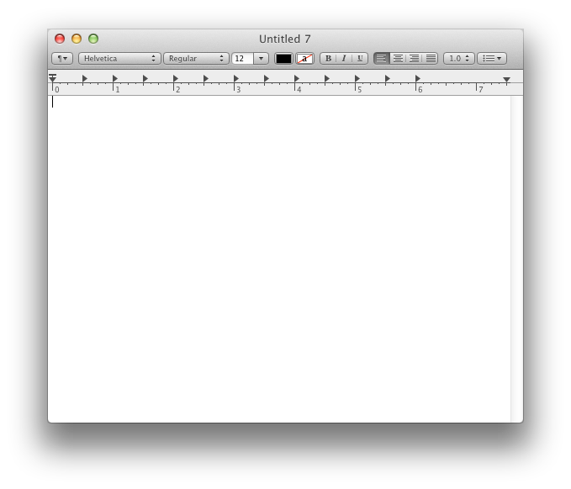

**2) You should see something like this.**

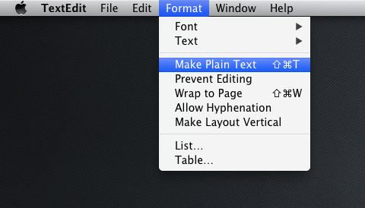

**3)** Changing to plain text - the first thing we are going to do is change this to **Plain Text.** To do this, click on **Format** on the toolbar and click on **Make Plain Text**.

**4)** If you did this correctly, the toolbar in TextEdit should vanish.

**Before (Wrong)**

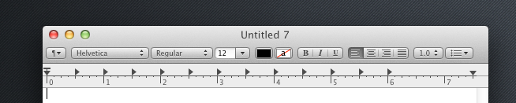

**After (Correct)**

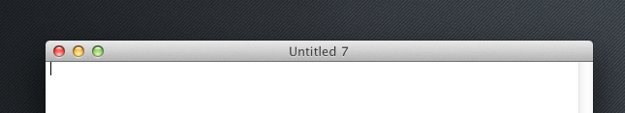

**5) Now we can start coding!**

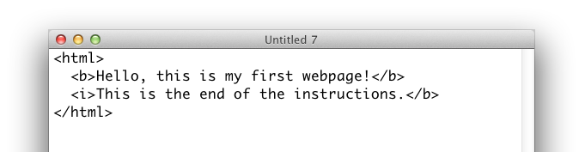

**6)** Now that we have some code, let’s save the file. To save, go to **File >> Save**

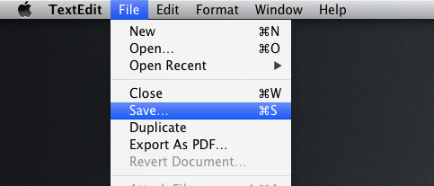

**7)** A dialog similar to the one below should pop up. You can name it whatever you want, but we will name it **index.html**. Make sure whatever you decide to name it, that it **ends with an html extension.** We are saving the file in **~/Desktop/www**, but you can save it anywhere, just make sure you can find it later.

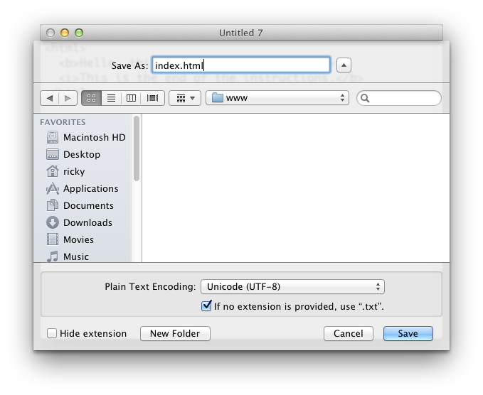

**8)** **Click save.** A dialog similar to the one below will pop up. Make sure you click the **Use .html button.**

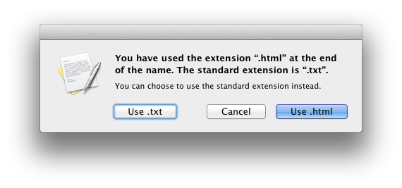

**9) That’s it! Your file should be saved =). If you decide to make more changes to the file, just go to File >> Save and the file will be saved.**